Avatars

What kinds of avatars are appropriate?
Match each avatar with a purpose and audience in the table below. Copy and paste your chosen image into the table. When you are happy with your choices, compare your choices with classmates.
 | 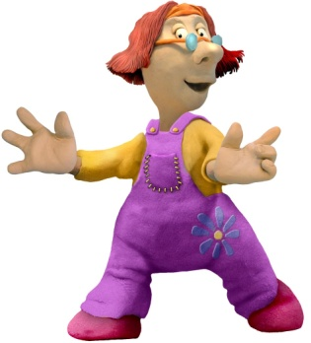 | 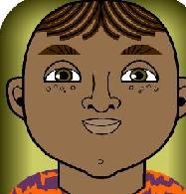 | 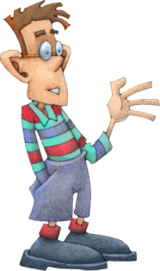
 |  |  | 
 |  |  | 
 |  | 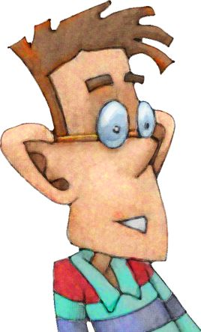 | 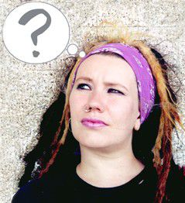

Avatar | Purpose | Audience
 | You are required to contribute to a class wiki for a Science assignment and need an image as part of your online profile. | Year 9 Science teacher and classmates.
 | You want to contribute to a public blog about environmental sustainability. | World wide web
 | You need to have an avatar to play an online game. | Members of the online game.
 | You need to have an avatar for your English assignments. | Your English teacher and classmates.
 | You want to contribute to a website about film reviews and need an image as part of your online profile. | World wide web.
 | You want to set up your own website and want to display your identity in a visual way. | World wide web.

