Multiplying and dividing decimals

Overview
This Stage 3 and 4 resource explores strategies for multiplying and dividing decimals with and without digital technology. Throughout this sequence, students will investigate the effect of multiplying and dividing numbers by whole numbers, powers of 10 and decimals. The distributive property, associative property and links with benchmark fractions will be used to support mental strategies.

Using this resource
This resource supports students’ understanding that multiplying and dividing decimals by 10, 100 and 1000 changes the positional value of the numerals, build knowledge of place value, and understand the magnitude of decimals when multiplying and dividing decimals with and without digital technology and develop estimation and rounding to check the reasonableness of answers, as well as a range of flexible strategies to multiply decimals without using technology.

Evidence base
- Steinle, V. (2004). Detection and remediation of decimal misconceptions. In B. Tadich, S. Tobias, C. Brew, B. Beatty, & P. Sullivan (Eds.), Towards excellence in Mathematics (pp460-478). Brunswick: The Mathematical Association of Victoria.
Alignment to system priorities and/or needs: The literacy and numeracy five priorities, Premier’s priorities: Increase the proportion of public school students in the top two NAPLAN bands (or equivalent) for literacy and numeracy by 15% by 2023.
Alignment to School Excellence Framework: Learning domain: Curriculum, Teaching domain: Effective classroom practice and Professional standards
Consulted with: Numeracy 7-12
Reviewed by: Literacy and Numeracy
Created/last updated: January 2023
Anticipated resource review date: January 2024
Feedback: Complete the online form to provide any feedback.

What works best
Explicit teaching practices involve teachers clearly explaining to students why they are learning something, how it connects to what they already know, what they are expected to do, how to do it and what it looks like when they have succeeded. Students are given opportunities and time to check their understanding, ask questions and receive clear, effective feedback.
This resource reflects the latest evidence base and can be used by teachers as they plan for explicit teaching.
Teachers can use classroom observations and other assessment information to make decisions about when and how they use this resource as they design teaching and learning sequences to meet the learning needs of their students.
Further support with What works best is available.

Differentiation
When using these resources in the classroom, it is important for teachers to consider the needs of all students, including Aboriginal and EAL/D learners.
EAL/D learners will require explicit English language support and scaffolding, informed by the Enhanced EAL/D enhanced teaching and learning cycle and the student’s phase on the EAL/D Learning Progression. Teachers can access information about supporting EAL/D learners and literacy support specific to EAL/D learners.
Learning adjustments enable students with disability and additional learning and support needs to access syllabus outcomes and content on the same basis as their peers. Teachers can use a range of adjustments to ensure a personalised approach to student learning.
Assessing and identifying high potential and gifted learners will help teachers decide which students may benefit from extension and additional challenge. Effective strategies and contributors to achievement for high potential and gifted learners helps teachers to identify and target areas for growth and improvement. A differentiation adjustment tool can be found on the High potential and gifted education website.

Using resources across learning areas
This resource may be used across learning areas where it supports teaching and learning aligned with syllabus outcomes. Literacy and numeracy are embedded throughout all K-10 syllabus documents as general capabilities. As the English and mathematics learning areas have a particular role in developing literacy and numeracy, NSW English and Mathematics syllabus outcomes aligned to literacy and numeracy skills have been identified.

Syllabus
MA3-1WM describes and represents mathematical situations in a variety of ways using mathematical terminology and some conventions
MA3-2WM selects and applies appropriate problem-solving strategies, including the use of digital technologies, in undertaking investigations
MA3-3WM gives a valid reason for supporting one possible solution over another
MA3-7NA compares, orders and calculates with fractions, decimals and percentages
MA4-1WM communicates and connects mathematical ideas using appropriate terminology, diagrams and symbols
MA4-2WM applies appropriate mathematical techniques to solve problems
MA4-3WM recognises and explains mathematical relationships using reasoning
MA4-5NA operates with fractions, decimals and percentages

NSW Mathematics K-10 Syllabus (2012)

Progression
Number and place value NPV8-NPV9
Additive strategies AdS9
Multiplicative strategies MuS6-MuS7
Interpreting fractions InF6, InF8
National Numeracy Learning Progression Version 3

Materials required
- coloured square grids with ones, tenths and hundredths
- decimal place slider (Resource 3)
- investigative tasks (Resource 1 & 2 – print class set)

Resource sequence
Teacher information:
This resource looks at developing various strategies to multiply decimals by a whole number and to multiply by another decimal up to 3 decimal places with and without digital technology.
To operate division of decimals by a whole number, students must use their knowledge of division as the inverse operation of multiplication. However, division of decimals by another decimal is quite complex and students should use a calculator for this.
Prior knowledge of decimal place value and understanding of the magnitude of decimals is essential when multiplying with decimals.
Some flexible strategies can be used to multiply decimals. However, prior knowledge of two properties is essential in performing these operations:
Distributive property of multiplication: We can multiply two numbers by expressing one (or both) as a sum and then multiply each part of the sum by the other number (or each part of its sum). For example, $8 × 17 = 8 × \left(10 + 7\right)$
$$= \left(8 × 10\right)+ \left(8 × 7\right)$$
$$= 80 + 56$$
$$= 136$$
Associative property of multiplication: When $a\left(bc\right)= \left(ab\right)c$ for all numbers $a, b$ and c. For example, $1.50 × 40 = 1.50 ×\left(10 × 4\right)$
$$= \left(1.50 ×10\right)× 4$$
$$= 15 × 4$$
$$= 60.0$$
It is important to note that:
Stage 3 students will learn to multiply decimals by whole numbers and perform divisions by non-zero whole numbers where the results are terminating decimals, with and without the use of digital technologies, for example $3.5 × 2$, $3 × 1.25$, $5.25 ÷ 5$. They will also multiply and divide decimals by powers of 10 by recognising patterns and use of a calculator
Stage 4 students will learn to multiply and divide decimals using written methods, whilst limiting operators to two digits. They should compare initial estimates with answers obtained by written methods and check by using a calculator.

Teaching strategies: Multiplying with decimals

Repeated addition

This involves finding the answer by adding the same number multiple times.
Without technology:
For example;
- 3 × 0.2 is the same as adding 0.2, 3 times (0.2 + 0.2 + 0.2 = 0.6).

- 5 × 1.27 is the same as adding 1.27, 5 times

- 0.05 × 10 is the same as adding $\frac{5}{100}+\frac{5}{100}+\frac{5}{100}+…= \frac{50}{100}=\frac{5}{10}$ (equal to 5 tenths)

Teacher Tip: Use the decimal place value slider to demonstrate that 5 hundredths have now changed to 5 tenths. Since the positional value of 5 has become larger it has moved to the left, however, the decimal point stays in the same spot. Students can also use the area model to develop conceptual understanding of change in positional value of digits in decimals.

With technology:
Students use repeated addition, a decimal place slider (Resource 3) and their calculator to investigate the result of multiplying decimals by 10, 100 and 1,000. From this activity, students should develop the conceptual understanding that multiplying decimals by 10, 100 and 1,000 changes the positional value of the digits. Use the table in Resource 1 and have students complete the table and discuss what they notice.

A decimal slider can:
- be useful for learning to multiply and divide by powers of 10.
- illustrate that multiplying and dividing by powers of 10 does not move the decimal point (common misconception).
- highlight the importance of:
  - having a zero in the ones columns (for example, 3.2 ÷ 10 = .32)
  - filling any gaps between the original digits and the ones column with zeros (for example, 3.2 x 1000 = 3200).
  - removing unnecessary zeros or the decimal point (for example, 3.2 x 10 = 32)

Steinle, V. (2004). Detection and remediation of decimal misconceptions. In B. Tadich, S. Tobias, C. Brew, B. Beatty, & P. Sullivan (Eds.), Towards excellence in Mathematics (pp460-478). Brunswick: The Mathematical Association of Victoria

Once students have completed the table, they should make the connection using the strategies mentioned to show the change in the positional value digits. Students should recognise that when multiplying by 10, 100 or 1000 the digits move to the left once, twice or thrice respectively.
Common misconceptions: Students see that when multiplying 0.05 x 10 the decimal point has moved one place to the right to get the answer 0.5. They need to understand that it is 10 lots of 5 hundredths that makes 5 tenths. Hence, it is the positional value of 5 that has changed from hundredths to tenths, and not the decimal point that has moved to the right.

Partitioning - split by parts
This involves breaking up the digits into parts and multiplying using the distributive property
or the associative property to multiply decimals.

Without technology:
For example;
- 4 x 2.1.
Using the distributive property, 4 x 2.1 is the same as
4 x (2.0 + 0.1) = (4 x 2.0) + (4 x 0.1) First we multiply the ones first, that is, 4 x 2 = 8
Next, we multiply the decimal, that is, 4 x 0.1 = 0.1 + 0.1 + 0.1 + 0.1 = 0.4 Add the two products together and we have 8 + 0.4 = 8.4
- 3.2 x 2.1
Using the distributive property, 3.2 x 2.1 is the same as (3 x 2.1) + (0.2 x 2.1)
So, 3 x 2.1 = 2.1 + 2.1 + 2.1 = 6.3 (using repeated addition)
Then multiply 0.2 and 2.1, which is the same as
$$(0.2 × 2) + (0.2 × 0.1) =\left(0.2+0.2\right)+\left(\frac{2}{10}×\frac{1}{10}\right)$$

$=0.4+\frac{2}{100}$

$=\frac{4}{10}+\frac{2}{100}$

$=\frac{40}{100}+\frac{2}{100}$

$$=\frac{42}{100}$$
$=0.42$

Hence, 3.2 x 2.1 = 6.3 + 0.42 = 6.72

Round to whole numbers to estimate

- Multiply 4.91 by 5.1
Without technology:
Round up 4.91 to 5 and round 5.1 down to 5. So, this is approximately equal to 25.
With technology: Using your calculator, the exact value of 4.91 x 5 = 25.041 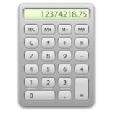
- Multiply 12 by 0.54

Without technology:
Now 0.54 (or 54 hundredths) is approximately half of a whole. So, half of 12 is approximately 6.

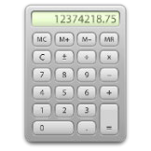
With technology: The exact value of 12 x 0.54 = 6.48

Teacher Tip: Students must understand that multiplying does not always make the number larger, for example, 15 x 0.5 is half of 15 which is 7.5).

Using benchmark fractions to operate with decimals

Benchmark fractions are fractions that are commonly used in estimating and making comparisons to other numbers. They can be converted to decimals that can be used to aid in mental computation.
Some examples are listed below:

- $\frac{1}{2}$is the same as 0.5

- $\frac{1}{4}$is the same as 0.25

- $\frac{3}{4}$ is the same as 0.75

- $\frac{1}{10}$ is the same as 0.1

- $\frac{1}{100}$ is the same as 0.01

- These benchmark fractions are useful when estimating decimals and when doing mental
computations involving decimals. For example, to find 16 x 0.25, we know that 0.25 is $\frac{1}{4} ,$
hence $\frac{1}{4}$ of 16 is 4.

These decimals can also be used when performing division. For example, to find 0.5÷0.25, we can see that it is asking us how many quarters go into one-half. The answer is 2.

Teaching strategies: Dividing with decimals

Dividing by 10, 100 and 1000
- Ask students to explain how multiplication and division are related. They can use numbers to describe the relationship.
Sample response: Division is the inverse of multiplication. For example, 3 x 2 is 6 and so 6÷3 =2

- Students multiply 0.5 by 10 using the slider (Resource 3) or any other strategy.

- Students explain what they think 0.5 ÷ 10 would be?
Teacher Tip: Students are encouraged to use the slider to explain the outcome. They can also use the calculator to see the connection. Emphasise the importance of putting a zero in the original spot as a place holder.
Sample response: Move the digit 5 one place to the right as the positional value of 5 gets smaller when dividing.
Students are given the following decimals to establish a pattern when dividing by 10, 100 or 1000. They should do this for decimals beyond 1 using the slider.
0.5 ÷ 100 = and 0.5 ÷ 1000 =
0.5 ÷ 10 = and 0.05 ÷ 100 =

- Students use the table in Resource 2 to establish a pattern when dividing by 10, 100 and 1000.
Sample response:
Calculation | Tens | Ones | Dec. point | Tenths | Hundredths | Thousandths | Outcome
0.5 |  | 0 | . | 5
0.5 x 10 |  | 5 | . | 0 |  |  | Move 5 to the left  once
0.5 ÷ 10 |  | 0 | . | 0 | 5 |  | Move 5 to the right  once
0.5 x 100 | 5 | 0 | . | 0 |  |  | Move 5 to  the left twice
0.5 ÷ 100
- Students should recognise from the above table that when dividing by 10, 100 or 1000, the digits move to the right once, twice or three times respectively. This table also shows the relationship when dividing and multiplying by 10 and 100. Get students to explain why this happens?

Sample response: The positional value of digit 5 in 0.5 gets smaller as you are dividing tenths by 10 again to give you hundredths.

Divide a decimal number less than 1 evenly by a single digit whole number
Problem: A piece of timber is 0.75 m long. It needs to be cut into 3 equal sections. How long is each part?
Without technology:
- Using benchmark fractions, express 0.75 as $\frac{3}{4}$ . Then $\frac{3}{4}$divided equally into 3 parts is $\frac{1}{4}$or 0.25.
- Using the area model, students use the 10 x 10 grid.
Sample response:
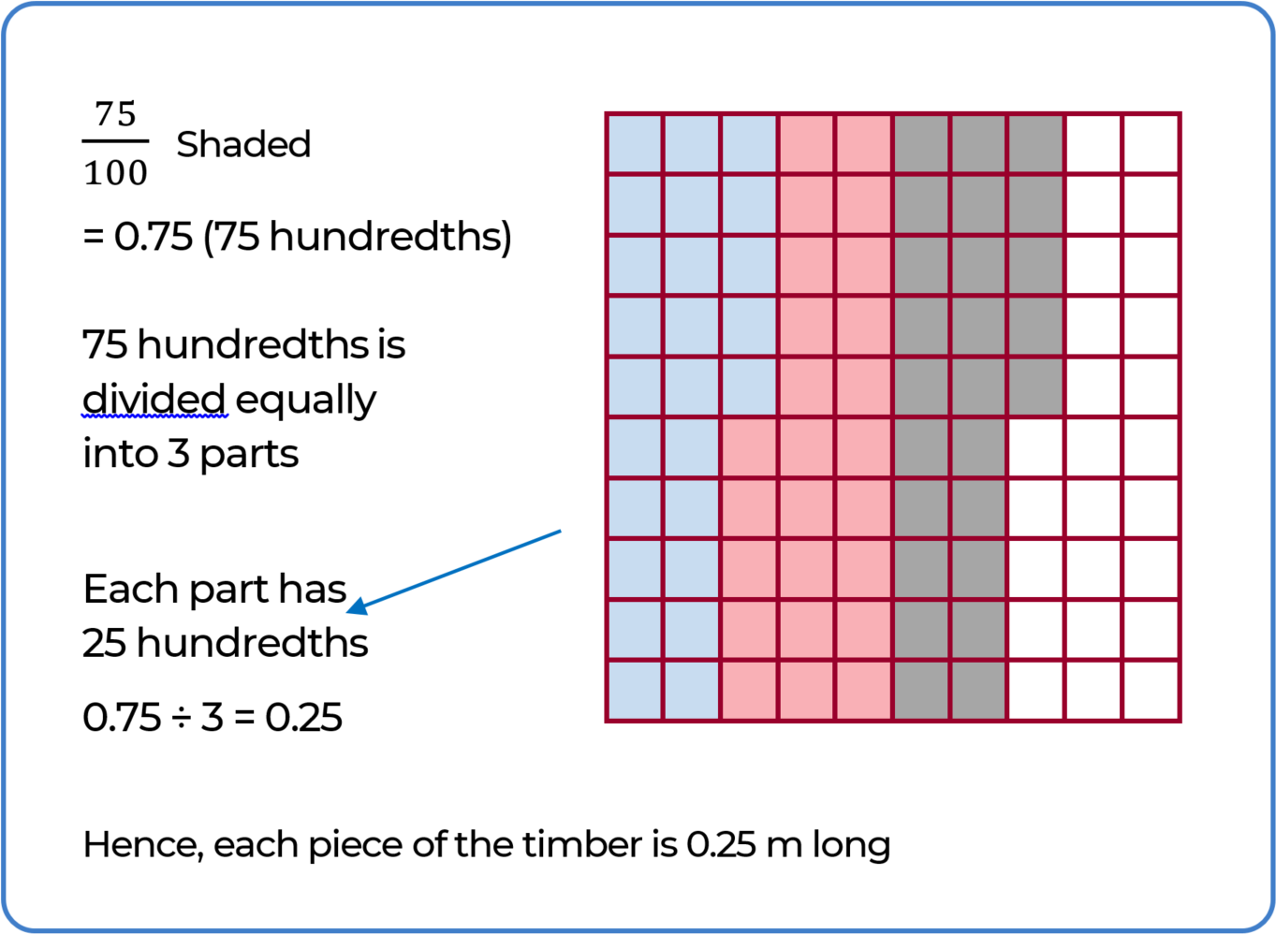

Divide a decimal by a whole number where the answer requires a smaller unit.
Problem: A farmer owned 0.7 acres of land. He wanted to split the land evenly for his two sons. How much land will each of his sons receive?

Teacher Tip: Ask students to demonstrate how they can split 7 tenths evenly into two halves using grid paper.
Sample response: If we use the tenths grid paper, we cannot divide into two halves exactly, so we use the hundredths grid (since 7 tenths is equal to 70 hundredths), then we can divide 70 into two halves exactly giving 35 hundredths.

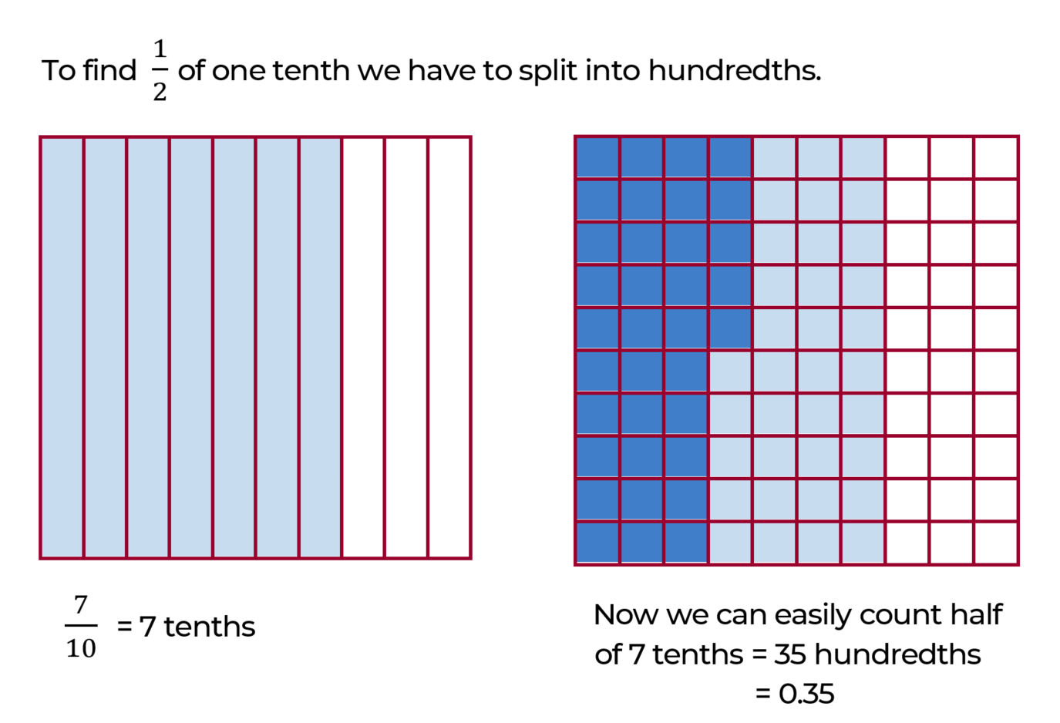

Divide a decimal number beyond 1 by a whole number.
Problem: Jane bought a box of playdough weighing 2.3 kg for a class activity. She had to divide the playdough equally amongst her 5 students. How much playdough did each of them receive?
Sample response: Express everything in tenths, that is, 2.3 is equal to 23 tenths.

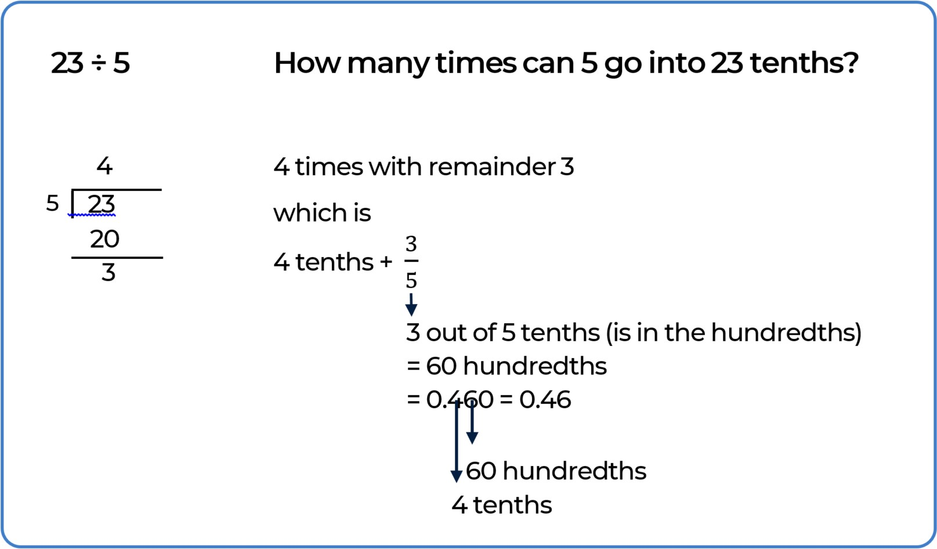

Resource 1: Investigative Task – Multiplying by 10, 100 and 1000

Calculation | Tens | Ones | Decimal point | Tenths | Hundredths | Thousandths | Ten thousandths
0.5 |  | 0 | . | 5
0.5 × 10 |  |  | .
0.5 × 100 |  |  | .
0.5 × 1000 |  |  | .
0.05 × 10 |  |  | .
0.05 × 100 |  |  | .
0.05 × 1000 |  |  | .

Resource 2: Investigative Task – Dividing by 10, 100 and 1000

Calculation | Tens | Ones | Decimal point | Tenths | Hundredths | Thousandths | Ten thousandths
0.5 |  | 0 | . | 5
0.5 ÷ 10 |  |  | .
0.5 ÷ 100 |  |  | .
0.5 ÷ 1000 |  |  | .
0.05 ÷ 10 |  |  | .
0.05 ÷ 100 |  |  | .
0.05 ÷ 1000 |  |  | .

Resource 3: Decimal place slider

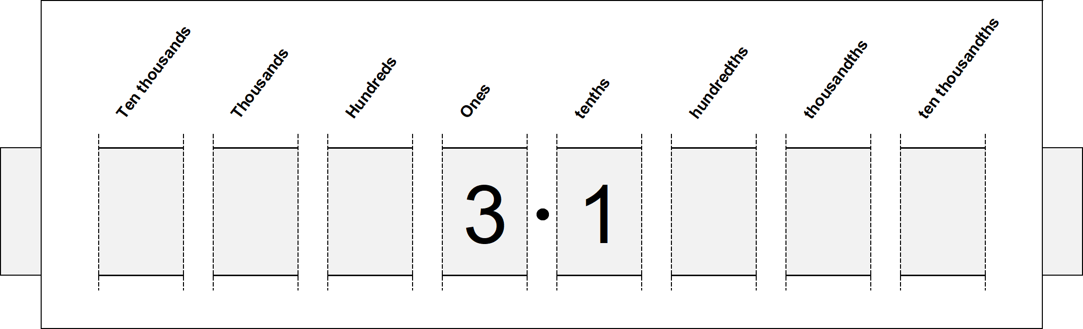

- See template on next page- cut along the dotted lines in order to slide strip of paper through the slider
- The digits of numbers are written on the strip of paper. This allows the digits to move as the strip of paper is pulled sideways
- Students can add arrows to the ends of strip of paper, that is an arrow on left hand side pointing to left to indicate the direction to slide for multiplication. Try for 3.1 × 10, 3.1 × 100
- Students can add arrows to the ends of strip of paper, that is an arrow on right hand side pointing to right to indicate the direction to slide for division. Try for 3.1 ÷ 10, 3.1 ÷ 100
- This tool supports student understanding that the decimal point is fixed between the ones and the tenths and that it is the digits that move to other columns.
