Stage 2 Addition and subtraction with money

Overview
This Stage 2 resource consists of a three-part sequence: comparing money, how much money and time to shop.

Using this resource
In Stage 2, it is important that students apply and extend their repertoire of mental strategies for addition and subtraction. The use of concrete materials, number lines and bar models to model the addition and subtraction of 2 or more numbers, with and without trading, is intended to provide a foundation for the introduction of the formal algorithm.

Evidence base
Brady, K., Faragher, R., Clark, J., Beswick, K., Warren, E., Siemon, D. (2015). Teaching Mathematics: Foundations to Middle Years. Australia: Oxford University Press.
Alignment to system priorities and/or needs: The literacy and numeracy five priorities.
Alignment to School Excellence Framework: Learning domain: Curriculum, Teaching domain: Effective classroom practice and Professional standards
Consulted with: Numeracy P-6
Reviewed by: Literacy and Numeracy
Created/last updated: January 2025
Anticipated resource review date: January 2026
Feedback: Complete the online form to provide any feedback.

What works best
Explicit teaching practices involve teachers clearly explaining to students why they are learning something, how it connects to what they already know, what they are expected to do, how to do it and what it looks like when they have succeeded. Students are given opportunities and time to check their understanding, ask questions and receive clear, effective feedback.
This resource reflects the latest evidence base and can be used by teachers as they plan for explicit teaching.
Teachers can use classroom observations and other assessment information to make decisions about when and how they use this resource as they design teaching and learning sequences to meet the learning needs of their students.
Further support with What works best is available.

Differentiation
When using these resources in the classroom, it is important for teachers to consider the needs of all students, including Aboriginal and EAL/D learners.
EAL/D learners will require explicit English language support and scaffolding, informed by the Enhanced EAL/D enhanced teaching and learning cycle and the student’s phase on the EAL/D Learning Progression. Teachers can access information about supporting EAL/D learners and literacy support specific to EAL/D learners.
Learning adjustments enable students with disability and additional learning and support needs to access syllabus outcomes and content on the same basis as their peers. Teachers can use a range of adjustments to ensure a personalised approach to student learning.
Assessing and identifying high potential and gifted learners will help teachers decide which students may benefit from extension and additional challenge. Effective strategies and contributors to achievement for high potential and gifted learners helps teachers to identify and target areas for growth and improvement. A differentiation adjustment tool can be found on the High potential and gifted education website.

Using resources across learning areas
This resource may be used across learning areas where it supports teaching and learning aligned with syllabus outcomes. Literacy and numeracy are embedded throughout all K-10 syllabus documents as capabilities. As the English and mathematics learning areas have a particular role in developing literacy and numeracy, NSW English and Mathematics syllabus outcomes aligned to literacy and numeracy skills have been identified.

Syllabus
MAO-WM-01 develops understanding and fluency in mathematics through exploring and connecting mathematical concepts, choosing and applying mathematical techniques to solve problems, and communicating their thinking and reasoning coherently and clearly
MA2-AR-01selects and uses mental and written strategies for addition and subtraction involving 2- and 3-digit numbers
NSW Mathematics K-10 Syllabus (2022)

Progression
Understanding money UnM4-UnM7
National Numeracy Learning Progression Version 3

Copyright
Section 113P Notice
Texts, Artistic Works and Broadcast Notice
Some of this material has been copied and communicated to you in accordance with the statutory licence in section 113P of the Copyright Act. Any further reproduction or communication of this material by you may be the subject of copyright protection under the Act. Do not remove this notice.

Materials required
- writing materials
- Appendix 1: What would you rather?
- Appendix 2: Shopping

Resource sequence

Comparing money
- Use Appendix 1: What would you rather? to complete the activity.
- Ask students without counting the money which they would rather A or B?
- Ask students to record their choice and explain their mathematical thinking.

How much money?
- Say to the students, in my pocket I have $36. Ask:
- What notes or coins might I have?
- What notes or coins might be in my pocket if I have a total of 10 notes and coins?
- What notes or coins might be in my pocket if I have a total of 15 notes and coins?
- Find as many different possibilities as you can to make $36.
- Use a table to record the different possibilities for each note and coin.

Time to shop
- Ask students to look at Appendix 2: Shopping and focus on the grocery items and their prices.
- Ask students to select 4 items to buy:
- What is the total cost of the 4 items?
- How much change would you get from $20 if you bought these 4 items?
- How close can you get to spending $20 using these groceries?
- What is the least amount of items you could buy for a total of $20 when you can only buy 1 of any item?
- What is the most amount of items you could buy for a total of $20 when you can only buy 1 of any item?
- What is the most amount of items you could buy for $20 if the products were all full price but they had run out of rice?
- How close to spending $20 could you get if you had to buy 2 of each item that you select?
- How many items can you buy if you have a total of $17.50 to spend but you could only buy 1 of any item that you choose?

Appendix 1: What would you rather?
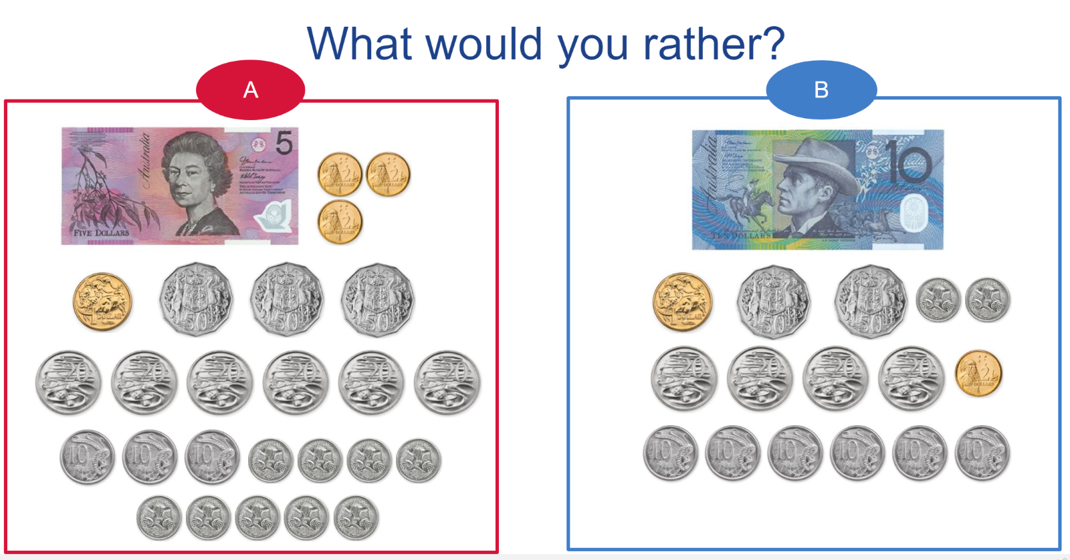

Appendix 2: Shopping
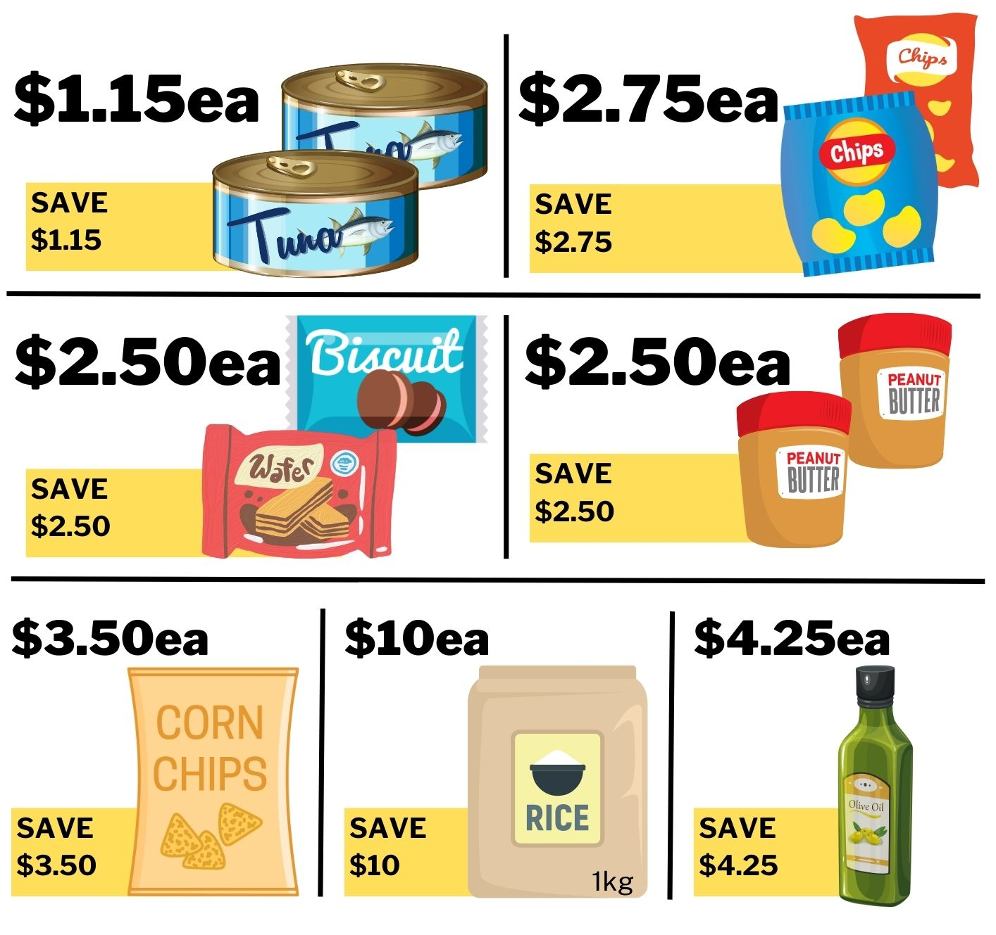
Images sourced from Canva and used in accordance with the Canva Content License Agreement.

