Applications with decimals

Overview
This Stage 3 and 4 resource requires students to apply knowledge of operations with decimals and place value to solve a variety of worded problems. Students will estimate their answers using mental or written methods and check the reasonableness of their answers using a calculator.

Using this resource
This resource supports student comprehension of decimal word problems using both Newman's error analysis and think boards. The resource is intended to be used with students who have a sound knowledge of working with decimals in the four operations, as well as strong estimation skills. Students will be able to read and comprehend a word problem involving decimals in various contexts and use flexible strategies to solve familiar and routine problems involving decimals.

Evidence base
- Askew, M. (2015). Transforming Primary Mathematics: Understanding Classroom Tasks, Tools and Talk. United Kingdom: Taylor & Francis.
Alignment to system priorities and/or needs: The literacy and numeracy five priorities, Premier’s priorities: Increase the proportion of public school students in the top two NAPLAN bands (or equivalent) for literacy and numeracy by 15% by 2023.
Alignment to School Excellence Framework: Learning domain: Curriculum, Teaching domain: Effective classroom practice and Professional standards
Consulted with: Numeracy 7-12
Reviewed by: Literacy and Numeracy
Created/last updated: January 2023
Anticipated resource review date: January 2024
Feedback: Complete the online form to provide any feedback.

What works best
Explicit teaching practices involve teachers clearly explaining to students why they are learning something, how it connects to what they already know, what they are expected to do, how to do it and what it looks like when they have succeeded. Students are given opportunities and time to check their understanding, ask questions and receive clear, effective feedback.
This resource reflects the latest evidence base and can be used by teachers as they plan for explicit teaching.
Teachers can use classroom observations and other assessment information to make decisions about when and how they use this resource as they design teaching and learning sequences to meet the learning needs of their students.
Further support with What works best is available.

Differentiation
When using these resources in the classroom, it is important for teachers to consider the needs of all students, including Aboriginal and EAL/D learners.
EAL/D learners will require explicit English language support and scaffolding, informed by the Enhanced EAL/D enhanced teaching and learning cycle and the student’s phase on the EAL/D Learning Progression. Teachers can access information about supporting EAL/D learners and literacy support specific to EAL/D learners.
Learning adjustments enable students with disability and additional learning and support needs to access syllabus outcomes and content on the same basis as their peers. Teachers can use a range of adjustments to ensure a personalised approach to student learning.
Assessing and identifying high potential and gifted learners will help teachers decide which students may benefit from extension and additional challenge. Effective strategies and contributors to achievement for high potential and gifted learners helps teachers to identify and target areas for growth and improvement. A differentiation adjustment tool can be found on the High potential and gifted education website.

Using resources across learning areas
This resource may be used across learning areas where it supports teaching and learning aligned with syllabus outcomes. Literacy and numeracy are embedded throughout all K-10 syllabus documents as general capabilities. As the English and mathematics learning areas have a particular role in developing literacy and numeracy, NSW English and Mathematics syllabus outcomes aligned to literacy and numeracy skills have been identified.

Syllabus
MA3-1WM describes and represents mathematical situations in a variety of ways using mathematical terminology and some conventions
MA3-2WM selects and applies appropriate problem-solving strategies, including the use of digital technologies, in undertaking investigations
MA3-3WM gives a valid reason for supporting one possible solution over another
MA3-7NA compares, orders and calculates with fractions, decimals and percentages
MA4-1WM communicates and connects mathematical ideas using appropriate terminology, diagrams and symbols
MA4-3WM recognises and explains mathematical relationships using reasoning
MA4-5NA operates with fractions, decimals and percentages

NSW Mathematics K-10 Syllabus (2012)
HT3-5 applies a variety of skills of historical inquiry and communication
HT4-8 locates, selects and organises information from sources to develop an historical inquiry
HT4-10 selects and uses appropriate oral, written, visual and digital forms to communicate about the past
NSW History K-10 Syllabus (2012)
FT4-6 relates the nutritional value of foods to health
FT4-8 collects, interprets and uses information from a variety of sources
NSW Food Technology 7-10 Syllabus (2019)

Progression
Number and place value NPV7-NPV9
Additive strategies AdS9
Multiplicative strategies MuS7-MuS8
Proportional thinking PrT4, PrT6
Understanding money UnM6
Understanding units of measurement UuM6
National Numeracy Learning Progression Version 3

Materials required
- calculator
- ruler and pencil
- notebook
- Resource 1 & 2 (print class set)

Resource sequence
- Teacher information
Decimals are commonly used in money applications and to record metric quantities and have applications in areas that can range from shopping to nutritional advice to expressing tolerances in precision engineering.
Using rules and procedures to calculate with decimals is not always appropriate. Decimal understanding needs to be developed with a firm understanding of place value and a strong understanding of the connection between decimals and fractions.
Developing a complete understanding of decimals requires both understanding and using notational conventions of the place value system of recording, as well as grasping the underlying fraction concept of, say ‘seven-tenths, and the structure of composite units. When comparing decimals such as, 0.24 and 0.08, students should regard 0.24 as 24 hundredths to accommodate the multi-unit place value. It is important to consider that money concepts are often linked with measurement due to the nature of dollars and cents being units. Money also is limited to two decimal places in a practical application but in the world of finance may extend beyond. When talking about money we need to recognise the misconceptions that may occur when we talk about money i.e., $0.50 is 50 cents but as a decimal we would say 0.50.
- Definitions
- Mean – The arithmetic mean of a list of numbers is the sum of the data values divided by the number of scores in the list. In everyday language, the arithmetic mean is commonly called the average. For example, for the following set of scores {2, 3, 3, 6, 8}, the mean is $\frac{2+3+3+6+8}{5}=\frac{22}{5}=4.4$
Source: https://educationstandards.nsw.edu.au/wps/portal/nesa/k-10/learning-areas/mathematics/mathematics-k-10/glossary
- Scale- A scale on a map that says 1: 100 000 is in the form of a ratio. A ratio is a comparison of numbers in a definite order. The numbers are expressed in the same units. The units used to measure distance on a map are usually in centimetres. We would not give the actual distance between two places in centimetres, we convert the scale of 1 cm on a map to metres of kilometres in real life.
So, 1 cm on the map represents 100 000 cm in real life, is the same as
1 cm on a map represents 1 km in real life (100 000 cm = 1 000 m = 1 km)

For each of the problems provided in this resource, students are encouraged to use one of the two problem solving methods below:
- Newman’s Error Analysis
- Think board
- Teacher Tip: Students can work in small groups and solve the activities using one of the above methods and then swap their working with a group that is using the alternative method. Students discuss the effectiveness of the tools used and any challenges or benefits. Groups can then repeat the process for the next activity, this time using the other method.

- Newman’s Error Analysis
Use Newman’s prompts to guide students through the five basic steps when solving word problems:
Note: There is a Newman’s Error analysis template in Resource 1 for students to complete each step of the problem-solving process. This will help teachers identify where errors or misconceptions may occur in students’ attempts to solve word problems.

Newman’s Error Analysis | Responses
Reading | Read the question and identify any words you don’t understand
Comprehension | Highlight key words, values and information. In your own words, explain what the question is asking you to find out?
Transformation | First estimate what you think the answer should be. What could you do to get the answer? What mathematical operations could you use?
Processing skills | Show clear and structured working out to find the answer. You can use a calculator at this stage to check your answer.
Encoding | Write down your answer and check to see if it makes sense. Validate your estimation and check if used the correct units and in the right format.

Example: Kerry spent 0.8 of her savings on a car and 0.5 of the remainder on a carport. She still had $1300 left. How much did Kerry spend on the car?

Steps | What a student should do
Reading | Read out the question and identify any words they don’t understand.  For example, the words ‘carport’ and ‘remainder’ may need to be explained.
Comprehension | Highlight key words, values or information. Then explain what the question is asking you to find out.  The values 0.8, 0.5 and $1300 should be highlighted and that the question is asking you to find how much Kerry spent on the car. Discuss the concept of remainder in the context of this question.
Transformation | Think about what mathematical operations you have to perform and how many steps are involved in getting the answer. Estimate what you think the answer should be by using mental or written strategies.  For this question I need to understand that the remainder is 0.2 (i.e., 0.8+0.2=1); 0.5 is one half, so one half of the remainder is 0.1. This means that $1300- the savings- also represents 0.1. So, if 0.1=$1300 then 1 whole is $13 000 and an estimate of the car would be $10 000 (i.e., 0.8)
Processing skills | Show clear and structured working to find the answer. You can use a calculator to get the exact answer.  The working should be set out like this:  If 0.1= 1300 then 0.8 = 8 x 1300= $10 400 (then use a calculator to check your answer)
Encoding | Write down the answer and check that it makes sense. How close was your estimate to your answer? Is my answer reasonable and have I used the correct units or is it in the right format?  Kerry spent $10 400 on her car and this is close to my estimate.  (This could lead to further discussion about the question: Kerry has $1300 in savings, a carport that cost $1300 and a car that cost $10 400. Before she bought the car, she had $13 000 in savings)

- Think board
A think board is used to encourage students to make connections between different ideas within mathematics and between mathematical concepts. The think board is a useful tool for helping students to think about a problem, make connections and to show their understanding.
An example of how a school has used think boards to support student numeracy development can be found on the NSW Department of Education website for the HSC Minimum Standard on the Literacy and numeracy webpage. Module 8 of the school discoveries series - Supporting students’ numeracy development.
A think board is a type of graphic organiser. You can access simple graphic organisers on the Digital learning selector on the NSW Department of Education website.
A think board is broken into four sections to support understanding of a problem.
- Question – write down what you are asked to find
- Get the info (information) – Write down all relevant information and values and maybe draw a diagram to make connections. At this stage students should be encouraged to estimate their answer using strategies such as rounding.
- Do the Maths – perform calculations using correct mathematical operations and sequence steps to get the correct answer to the problem. Use a calculator to check the answer.
- Write the answer – check whether you have answered the question correctly. Validate your estimation and check the reasonableness of your answer.
Example: Mt Everest is the world’s highest mountain and a particularly desirable peak for mountaineers. The highest point of the mountain (summit) is 8 848 m above sea level. Many people who attempt to climb Mt Everest only reach Base Camp, which is 5 380 m above sea level. What percentage of the mountain do mountaineers climb when they reach base camp?
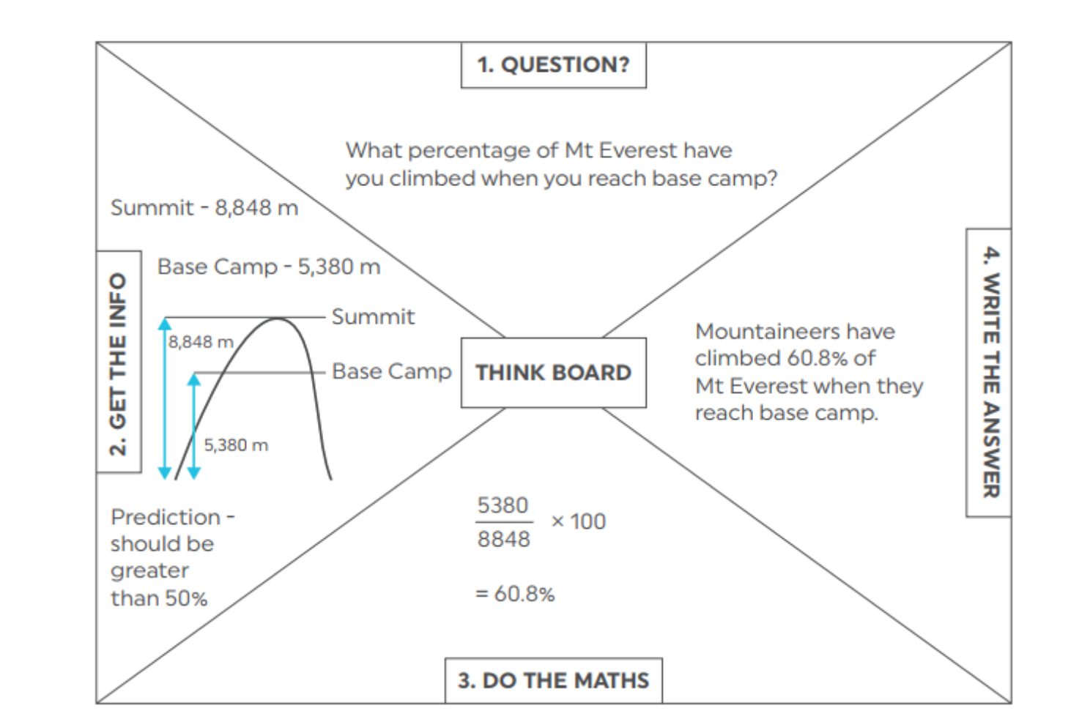

Student activities
Use either a think board or Newman’s prompts solve the following problems. Estimate your answers before performing exact calculations. You can use a calculator to check your calculations and validate your estimations.

Activity 1: Temperature readings
Problem: The temperature of a patient was monitored every half hour in the morning. The times and temperature readings were recorded below.
Time | 8:00am | 8:30am | 9:00am | 9:30am | 10:00am
Temperature | 38.37$℃$ | 38.4$℃$ | 38.29$℃$ | 38.08$℃$ | 37.46$℃$
- When was the highest temperature recorded?
- Place the temperatures in ascending order.
- What was the temperature difference between the highest and lowest temperature of the patient?
- What was the average temperature for the patient?

Activity 2: Decimals involving change
Problem: Mike went to the Easter Show. He was given $150 spending money for the day. He spent money on the following items.
Return train ticket | $10.90
Entry ticket to the show | $32.00
Rides | 5 rides for $12.00 each
Food and drinks | $23.40
Show bag | $7.50
How much money did Mike have left at the end of the day?

Activity 3: Decimals in money – involving percentages
Problem: Mary went to her favourite store to buy some make-up. She purchased the following items.
Mascara | $24.60
Eyeliner | $18.45
Foundation | $63.70
Lipstick | $34.99
When she approached the counter to pay for the products, she was told that she has enough membership points to get 20% off a lipstick purchase or $10.00 off an eyeliner.
- Which option would give her the better saving?
- How much money did she spend altogether at the store with the reward she redeemed?

Activity 4: Reading and interpreting decimals in scales/maps – calculating distance using scales
Problem: The actual distance from Mojo Wildlife Park to a town called Tomakin is 5.4 km.
- What scale has this map used to represent the distance between the two places? What does this scale represent?
- Use a ruler to measure the distance from the two places to one decimal place.
- Calculate the actual distance between the two places using the scale given.
- Does this map represent the correct distance between the two places? If not, what has caused the actual distance to be different?
- What scale should be to represent the actual distance using this map?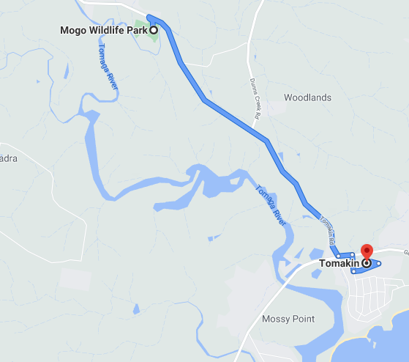
Map scale is 1:120 000

Activity 5: Decimals in timelines
Problem: You have been asked to draw a timeline in your Commerce class showing the formation of major Australian political parties.
These are the following instructions:
- Draw a 15 cm line in your book
- Divide the line into 10 evenly spaced intervals, mark the beginning of the line with the year 1890. Add 10 years for each interval, the end of the timeline will be 1990.
- Mark the following periods on the timeline:
- 1890-Labour Party
- 1914-National Party
- 1923-The Coalition
- 1944-Liberal Party
- 1977-Australian Democrats
- 1990-Greens
Think about the following when constructing your timeline:
  - How far apart (in cm) is each interval on the timeline?
  - What scale should you use to create your timeline?
  - How may centimetres would represent a decade?
  - What length will 1 year represent?
  - Halfway between 1910 and 1920 should be marked between which two decimal lengths on the line?
  - Where will the formation of the National Party in 1914 lie, to 2 decimal places?
  - Between which two decimal lengths have you marked the formation of The Australian Democrats in 1977?

Activity 6: Decimals in nutrition
In Australia, we use kilojoules (kJ) to measure how much energy people receive from consuming food or drink. The kilojoule content of foods depends on the amount of carbohydrates, fats, and proteins found in the food and the portion size. Many other countries use calories (Cal) as a way of measuring the potential energy contained in food.
The conversions are as follows: 1 Cal (kilocalories) = 4.184 kJ (kilojoules)
Below is a nutrition label from a cookie container purchased by Sam. Use the information on the label to answer the following questions.
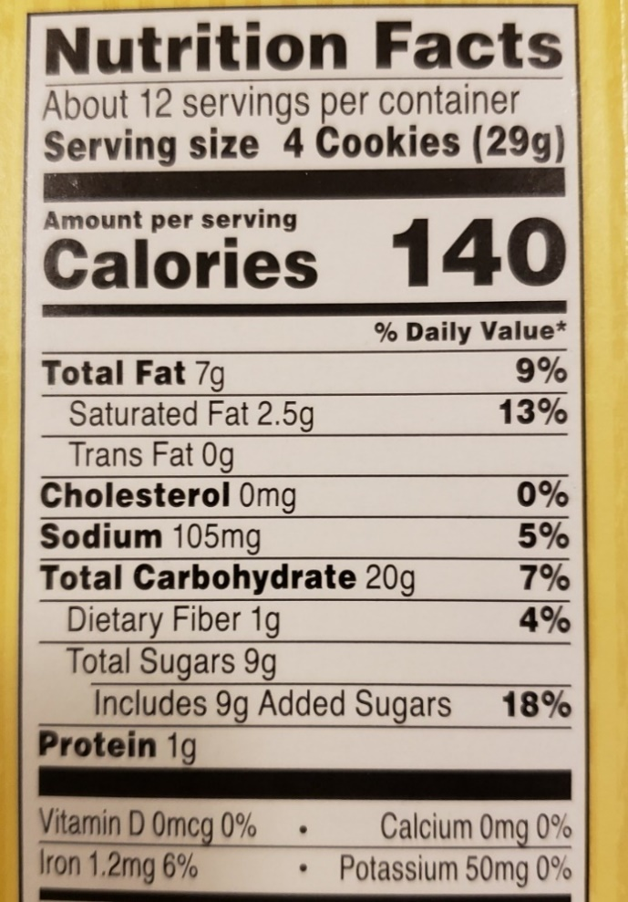
- How many cookies in one container?
- How much does one cookie weigh?
- How many grams of total fat in one cookie?
- If Sam ate the whole container of cookies in one week by himself, how many calories has he consumed? Calculate the total energy intake (in kJ) for one container of cookies, to 2 decimal places.
- How much total sugars has Sam consumed by eating the whole container of cookies
According to the World Health Organisation (WHO) guideline, it is recommended that adults and children reduce their daily intake of free sugars (sugars added to food and drinks by the manufacturer) to less than 10% of their total energy intake.
Reference: World Health Organisation. (2015). WHO calls on countries to reduce sugars intake among adults and children
https://www.who.int/news/item/04-03-2015-who-calls-on-countries-to-reduce-sugars-intake-among-adults-and-children
- Has Sam exceeded his energy intake of 10% by eating the whole container?
- Calculate how many teaspoons of sodium in one whole container of cookies.

Activity 7: Decimals in Science
Problem: The density of properties can be measured by dividing its mass by its volume. This means density is a measure of how much matter there is in an object (its mass) compared with how much space it takes up (its volume). It is measured in grams per cm³ (g/cm³).
Students in Mr Smith’s Science class were asked to conduct an experiment at home to calculate the density of various items around their home. One student recorded his results in a table as shown below

Material | Density
Vegetable oil | 0.927
Coconut oil | 0.924
Dish soap | 1.06
Skim milk | 1.033
Full cream milk | 0.994
Honey | 1.42
Ice | 0.9168
Water | 1.000
Butter | 0.911
Source of table: https://www.stevespanglerscience.com/lab/experiments/seven-layer-density-column/
Answer the following questions using the information from the table above:
- Which material has the highest density?
- What is the difference in density between ice and water? Explain why there is a difference.
- Order the density of these materials in descending order.

Activity 8: Decimals in calculating dosages
Problem: A 5-month-old baby weighs 7.2 kg. The baby was prescribed some Panadol for pain relief.
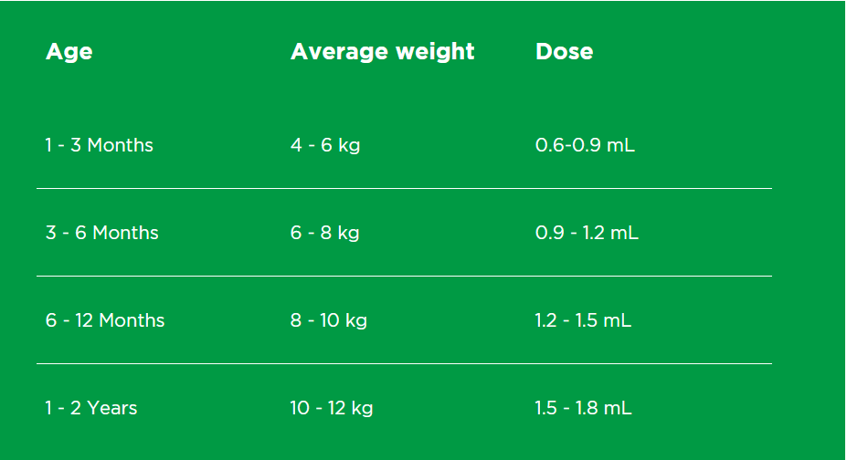
Source: https://www.panadol.com.au/products/children/colourfree-baby-drops-1-to-1-yr/
Part 1: Refer to the chart above to answer the following questions
- Explain why the chart gives the average weight and age for a dose of Panadol?
- Which is the most appropriate measure to determine the dosage of Panadol, i.e., weight or age of child?
- If the baby’s weight is 7.2 kg, what can a parent do to easily work out how much Panadol their child should take?
- How much Panadol should the baby be administered, correct to two decimal places?
Part 2: Use the syringes diagram below to answer the questions
- Which syringe is most suitable for measuring the Panadol accurately?
- Between which two markings should the Panadol syrup lie? Show this on the syringe.
- A parent uses syringe A and it is marked exactly at 1mL. Has the parent given the correct does of Panadol? If not, what would be the correct dose?
- What are the implications of rounding the baby’s weight?
- 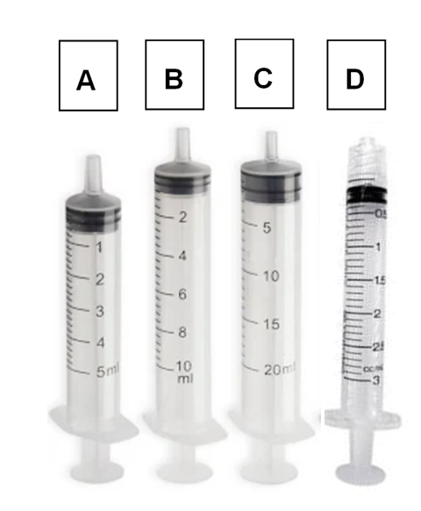

Activity 9: Decimals in time
Problem: Below is a table listing the results from the National Swimming Championships for different age groups. You will notice that most times are recorded in minutes seconds and hundredths of a second.
For example, 3:14.25 means that a swimmer took 3 minutes, 14 seconds and 25 hundredths of a second to complete the race. Note that 25 hundredths of a second is also called 25 centiseconds and 1 centisecond = $\frac{1}{100}$ of a second.
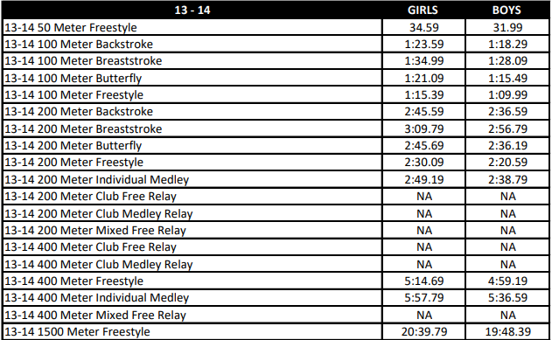
Source: https://image.aausports.org/dnn/Swimming/Swimming-TimeStandards.pdf
Use the table on the previous page to answer the following questions:
- Explain the significance of measuring swim time to one hundredth of a second (or centisecond)?
- For the 13-14 girls age group, write down the time taken to complete a 200 m Backstroke and a 200 m Butterfly.
- Round each of the times to the nearest second? Describe the rounding effect on the times recorded in the table?
- What is the time difference between girls and boys in the 13-14 100 m Freestyle, to the nearest centisecond?

Activity 10: Decimals in time
Problem: Five students scored 27, 21, 25, 26, 27 in a spelling competition.
- Calculate the mean score of all the students.
- For this school to win the competition next year, they have to increase their average by at least 10%. Determine the new average that they have to achieve by next year, correct to one decimal place.
- Determine the minimum score each student should obtain to reach their targeted mean score for the next competition. Should each of the scores be rounded up or down to reach the mean.
- Describe the impact of rounding down the scores on the mean.

Sample Answers
Teachers will need to assess student work, as students are completing these tasks using either Newman’s prompts or a think board.
- Activity 1:
- 38.4$℃$
- 37.46$℃$, 38.08$℃$, 38.29$℃$, 38.37$℃$, 38.4$℃$
- 38.4$℃$ - 37.46$℃$ = 0.94$℃$ (slightly less than 1$℃$)
- Average = $\frac{38.37+38.4+38.29+38.08+37.46}{5}=\frac{190.6}{5}=38.12℃$
- Activity 2:
Total expenditure = $10.90 + $32.00 + (5 x $12.00) + $23.40 + $7.50 = $133.80
Hence, $150.00 - $133.80 = $16.20
- Activity 3:
- 20% off the lipstick = 0.8 x $34.99 = $27.99, so that is a $7.00 saving. ($34.99 - $27.99 = $7.00) OR 20% off the lipstick = 0.2 x $34.99 = 6.998 =$7.00
Using a mental strategy: 10% off $34.99 is $3.49 (round to $3.50) then take another 10% off is $3.50 so that is a total of $7.00
$10.00 off $18.45 is $8.45, which is a saving of $10.00, rather than $7.00 off the lipstick.
Hence, the better saving is $10.00 off the eyeliner.
- Total expenditure = $24.60 + $8.45 + $63.70 + $34.99 = $131.74
- Activity 4:
- The scale of 1:120 000 means that 1 cm on paper represents 120 000 cm in real life. However, we don’t usually use centimetres as a unit of measure for long distances, we should convert that to metres or kilometres. Hence, 120 000 cm = 1 200 m = 1.2 km
- Using a ruler, the length should be 7.5 cm
- If 1 cm on the map represents 1.2 km in real life, then 7.5 cm represents (7.5 x 1.2) km, which is 9 km in real life.
- No, this map does not represent the correct distance. This is due to the incorrect scale being used, the scale is too large. In other words, 1 cm should represent a smaller length in real life.
- The scale should be more like 1: 70 000 or 1 cm on the map represents 0.7 km (or 700 m) in real life.
Then 7.5 cm represents (7.5 x 0.7) = 5.25 km in real life (which is closer to the actual distance)
- Activity 5:
- Each interval is 1.5 cm apart
- The scale is 1.5 cm represents one decade
- 1.5 cm = 15 mm
- 1.5 mm
- Halfway between 1910 and 1920 should be marked between 3.7 and 3.8 (i.e., 3.75)
- The formation of the National Party should be marked at 3.6 cm on the line
- About 13.2 cm from the start
- See an example image below
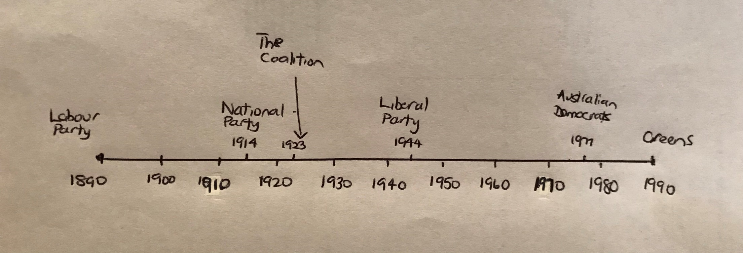
- Activity 6:
- 4 x 12 cookies = 48 cookies
- One cookie weighs $\frac{29}{4}=$7.25 g
- Total fat in one cookie is $\frac{7}{4}=$1.75 g
- He has consumed 140 x 12 Calories = 1 680 Calories (Cal).
The kilojoule intake is 4.184 x 1 680 = 7 029.12 kJ
- 9 g x 12 = 108 g of sugar
- $\frac{108}{7029.12 }×100=1.5\%$ (which is less than 10%)
- Amount of sodium in one container of cookies = 105 mg x 12 = 1 260 mg (which is a bit more than half a teaspoon of sodium)
- Activity 7:
- Honey has the highest density.
- Difference in density between ice and water is 0.0832 g (1.000 – 0.9168). This is because ice has a different structure to water, in that the molecules align themselves in a particular arrangement rather than more spread out and randomly in liquid form. Hence, ice is less dense than water.
- In descending order:
Material | Density
Honey | 1.43
Dish soap | 1.06
Skim milk | 1.033
Water | 1.000
Full cream milk | 0.994
Vegetable oil | 0.927
Coconut oil | 0.924
Ice | 0.9168
Butter | 0.911
- Activity 8:
Part 1:
- The chart provides both the age and corresponding weight ranges when calculating dosage of Panadol due to a couple of reasons. Firstly, if you do not know the baby’s weight you can go by the age of the baby to calculate the appropriate dosage. However, these age ranges may be used to help work out the paracetamol dose, but they are only a guide. If your child is small or lighter than average for their age, the dose may need to be based on a younger age (often the next age group down).
Secondly, it is recommended to calculate correct dosage based on baby’s weight not age (the usual dose of paracetamol for children is 10-15 mg per kilogram of weight).
We need to know that 10 mg = 0.01mL of liquid. So, for a 7kg baby, it should be between 0.07 mL and 1.05mL.
- The most appropriate measure is the baby’s weight to determine Panadol dosage
- The parent can round down the baby’s weight to 7 kg and then calculate the dose based on average weight in the middle of 6 and 8 kg.
- The amount of Panadol to be administered is exactly halfway between 0.9 and 1.2, which is 1.05 mL.
Part 2:
- The most suitable syringe to use is Syringe D
- The Panadol should be halfway between 1.0 mL and 1.1 mL
- It would be less by 0.05 mL
- Rounding down the baby’s weight from 7.2 kg to 7 kg has resulted in giving less Panadol than what the baby should receive.
- Activity 9:
- The swimming times have been recorded to one hundredth of a second because in competitive swimming, swimmers were tying when recorded to the nearest second, so they decided to introduce another level of accuracy in time (i.e., centisecond) to be able to distinguish between a gold and silver medallist.
- Backstroke: 2:45.59 and Butterfly: 2:45.69
- When rounded, Backstroke and Butterfly finish at the same time of 2:46 (i.e., 2 mins and 46 secs). The rounding effect shows that the times are exactly the same, but when measured to the hundredths digit, there is a slight difference in their times. This helps to determine who is the faster swimmer, by 10 hundredths of a second.
- The time difference between boys and girls time is 5 seconds and 40 centiseconds (0:05.40)
- Activity 10:
- The mean is $\frac{27+21+25+26+27}{5}= \frac{126}{5}=25.2$
- 25 x 1.1 = 27.7 (to 1 decimal place)
- After multiplying each score by 1.1, we have 29.7, 23.1, 27.5, 28.6, 29.7
Then each score should be rounded since you can’t get decimal values for spelling scores.
So, 30, 23, 28, 29, 30. This gives a mean of 28 (which is above the targeted mean of 27.7).
- If the scores were rounded down, then the mean would be less than 27.7.
For example, 30, 23, 27, 28, 30 (3 of the scores are rounded down). The mean for this is 27.6 (lower than the targeted mean score)

Resource 1: Newman’s Error Analysis
Newman’s Error Analysis | Responses
- Reading – read the question and identify any words you don’t understand
- Comprehension – highlight key words, values and information. In your own words, explain what the question is asking you to find out?
- Transformation – First estimate what you think the answer should be. What could you do to get the answer? What mathematical operations could you use?
- Processing skills – Show clear and structured working out to find the answer. You can use a calculator at this stage to check your answer.
- Encoding – Write down your answer and check to see if it makes sense. Validate your estimation and check if used the correct units and in the right format.

Resource 2: Think board template
